Module–1(Fundamental)

1. What is SDLC

* SDLC(software development life cycle)is the step-by-step process that shows the software development product like requirement gathering, analysis, design, implementation, testing, maintenance

1. What is software testing?
   * Software testing is a process use to identify correctness, completeness and quality of developed computer software
2. What is agile methodology?
   * Agile SDLC model is a combination of iterative and incremental process model. And mainly focused with adaptability and customer satisfaction by fast delivery of working software product.
3. What is SRS
   * Software requirement specification(SRS) is a complete description of the system to be developed.
4. What is oops
   * Object oriented programming systems .
5. Write Basic Concepts of oops

* Object, class, encapsulation, inheritance, polymorphism, abstraction.

1. What is object

* Object is an instances of a class.

1. What is class

* Class is an collection of data-member and member function with its behaviors.

1. What is encapsulation

* Private your data member and member function.

1. What is inheritance

* Properties of parent class extends into child class.

1. What is polymorphism

* Ability to take one name having many forms.

1. Draw Use case on online bill payment system (paytm)

* 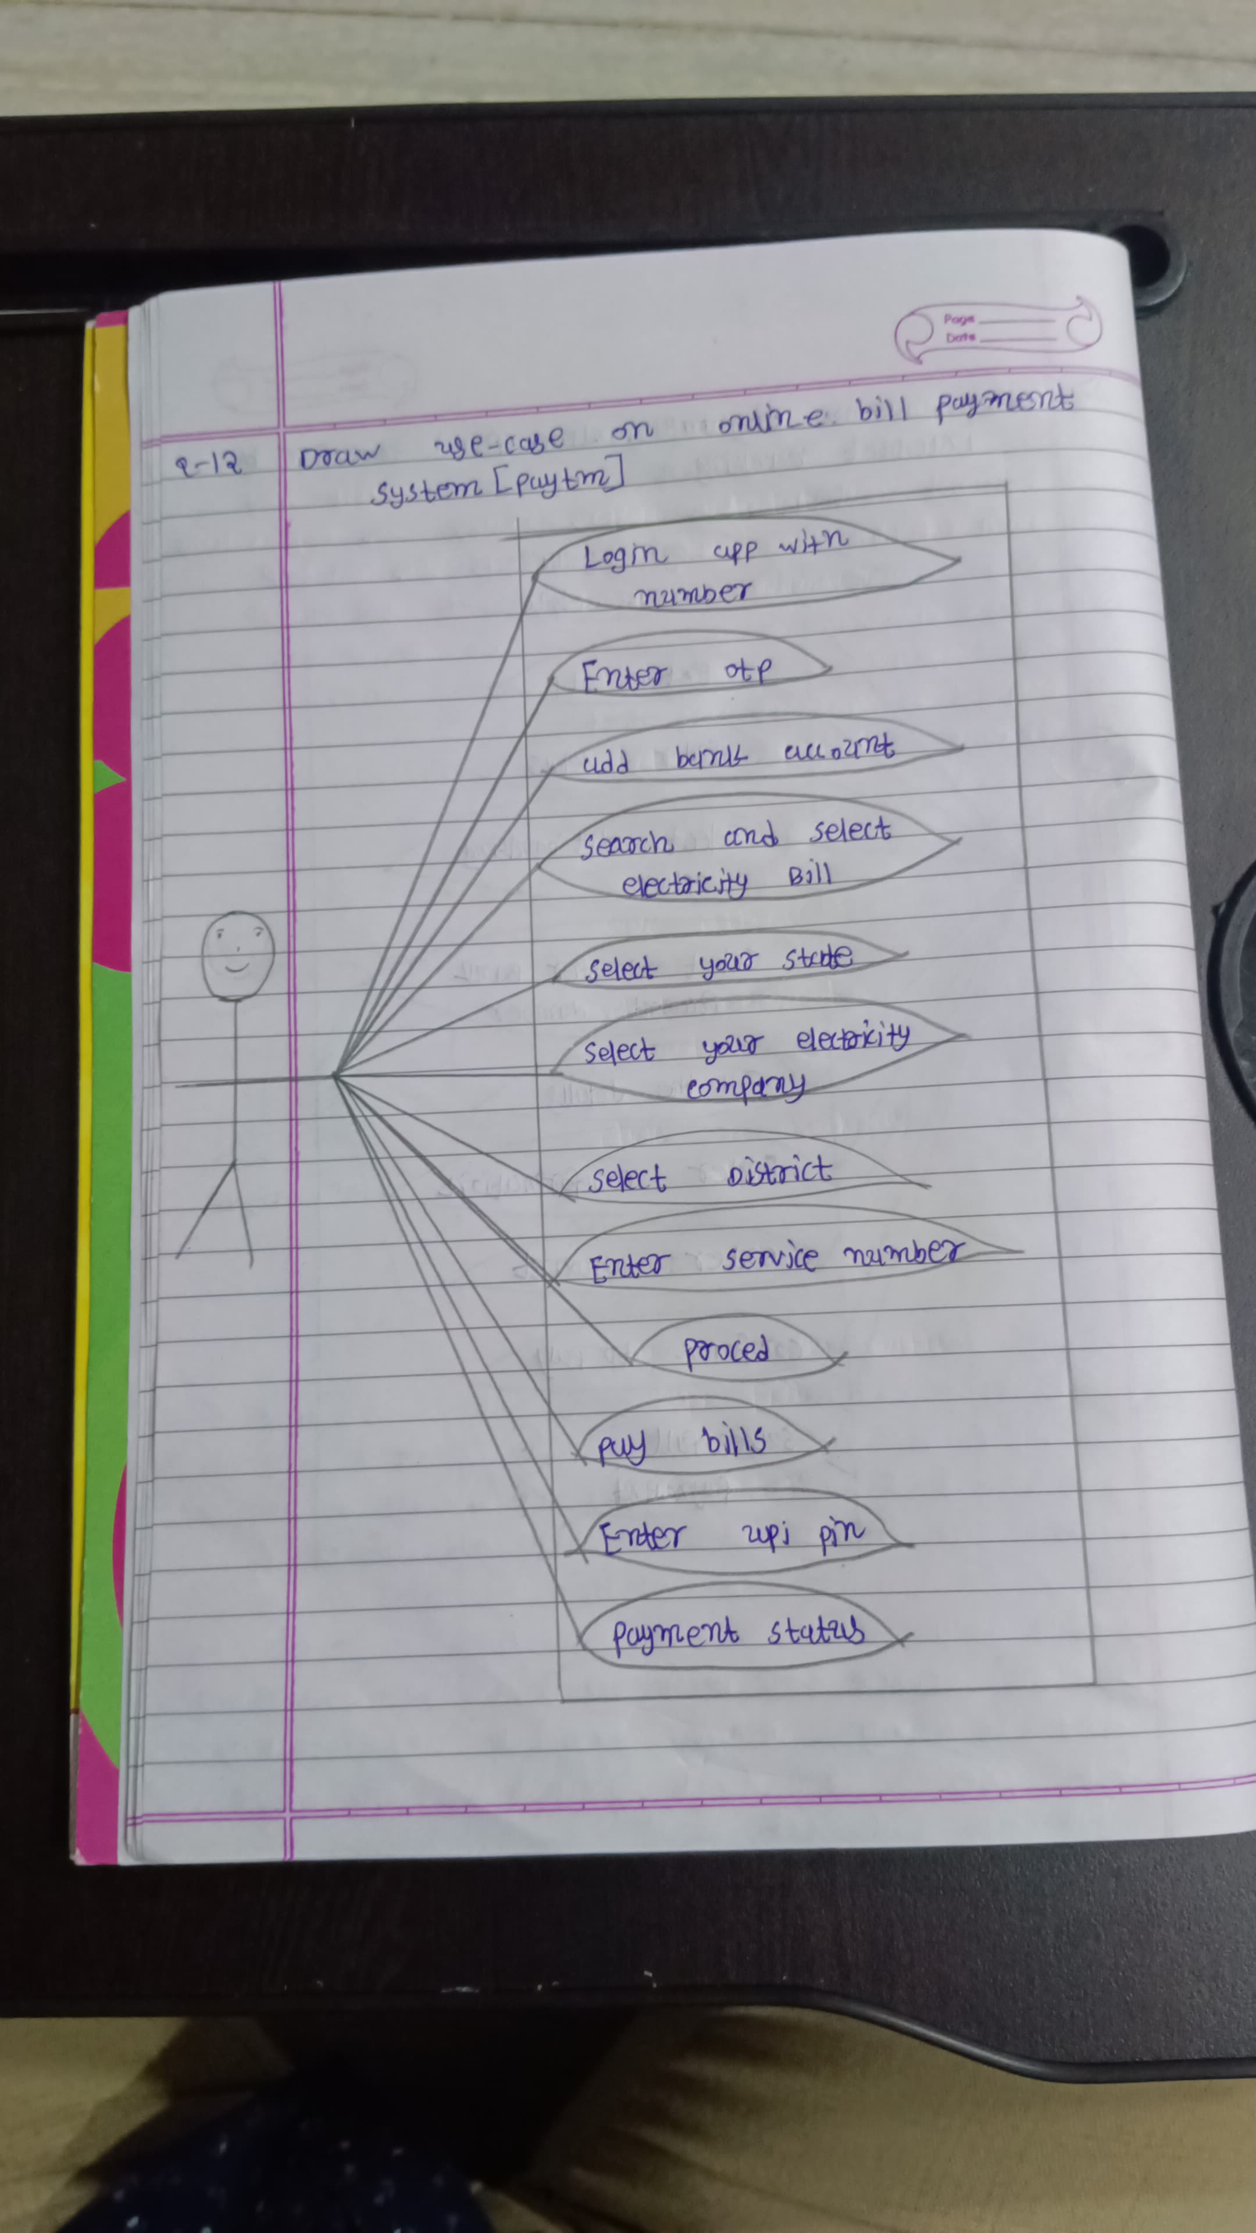

1. Draw Use case on banking system for customers.

* 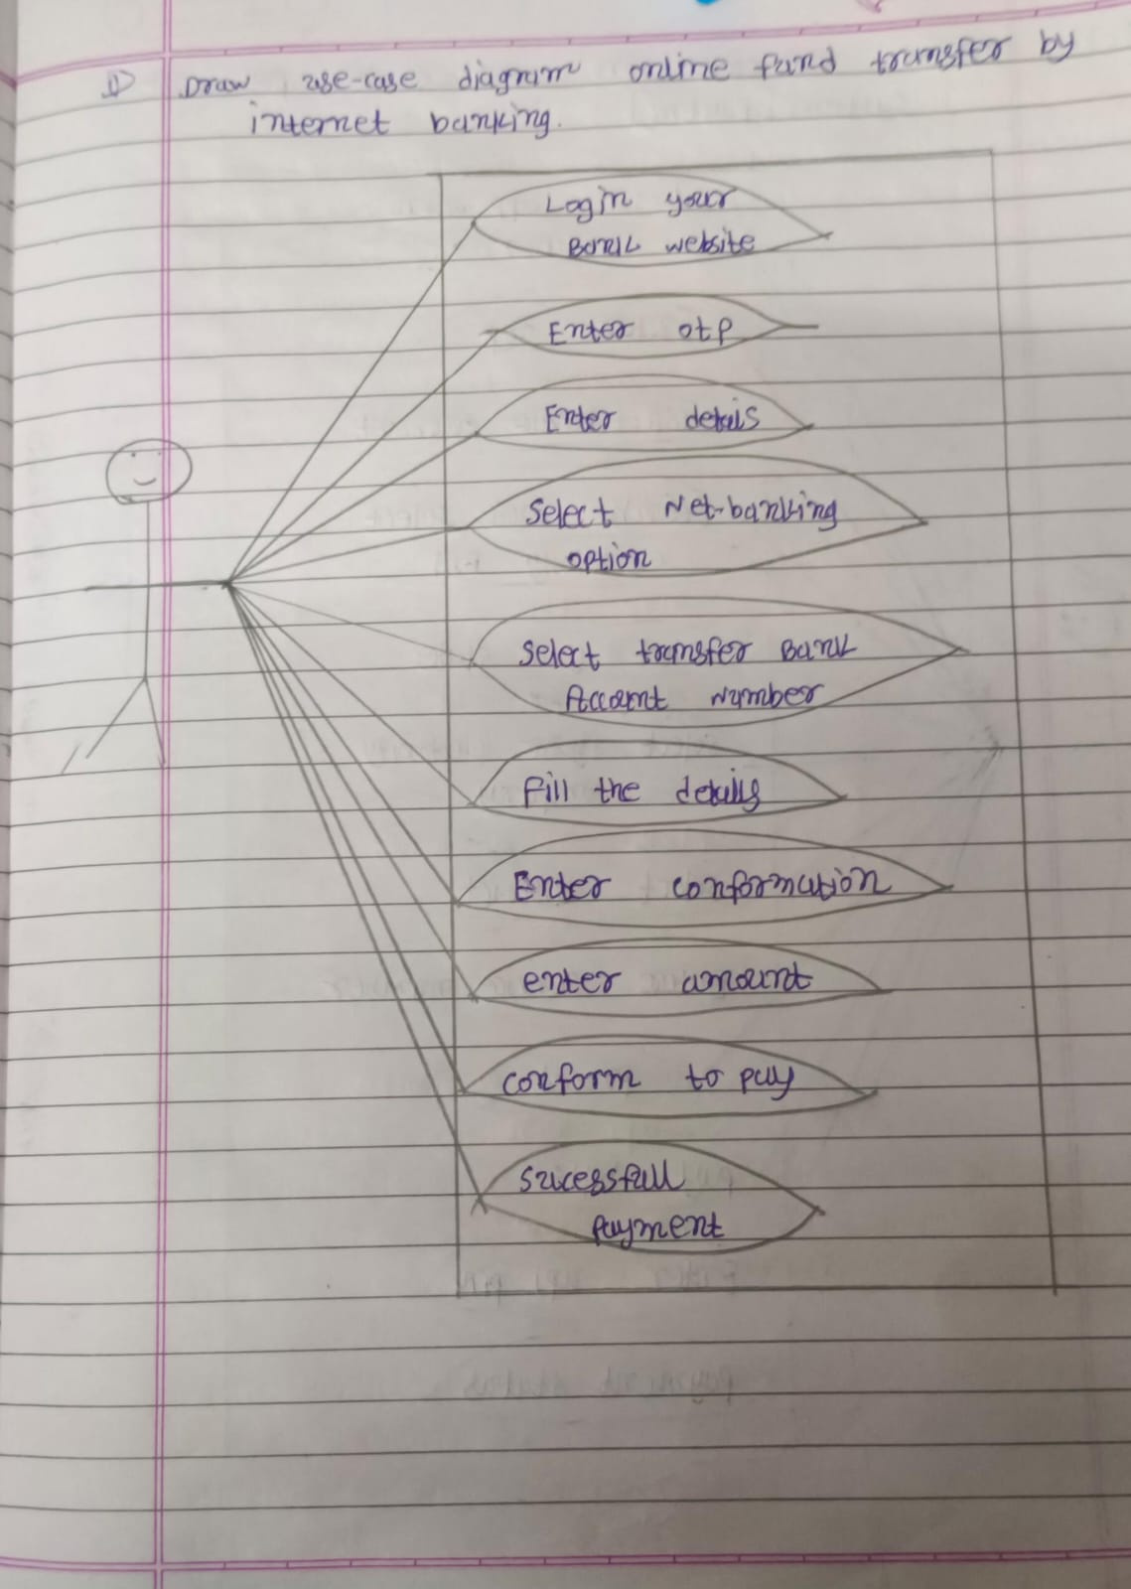

1. Draw Use case on Broadcasting System.
2. Write SDLC phases with basic introduction

* Phases of SDLC:-

Requirement gathering:- understanding needs of customer.

Analysis:-how much time taken for the project.

Design:-designing the diagram of project.

Implementation:-writing the code.

testing:- checking of the error.

maintenance:- solve the defects and find solution for new requirements.

1. Explain Phases of the waterfall model

* Phases of waterfall model:-requirement gathering, analysis, design, implementation, testing, maintenance.

1. Write phases of spiral model

* Phases of spiral model:-requirement gathering, analysis, design, implementation, testing, maintenance.

1. Write agile manifesto principles

* There are four types of manifesto :-

1. Individual interaction
2. Working software
3. Customer collaboration
4. Responding to change
5. Explain working methodology of agile model and also write pros and cons.

* Agile methods break the product into small part. These builds are provided in iterations. Each iteration typically lasts from about one to three weeks.

**Pros**:-

1. Is a very realistic approach to software development
2. Promotes teamwork and cross training.
3. Resource requirement are minimum.
4. Suitable for fixed or changing requirement

**Cons**:-

1. Not suitable for handling complex dependencies.
2. More risk of sustainability, maintainability and extensibility.
3. Depends heavily on customer interaction, and customer is not clear, team can wrong direction.
4. There is very high individual dependency, there is minimum documentation generated.
5. Draw use case on OTT Platform.

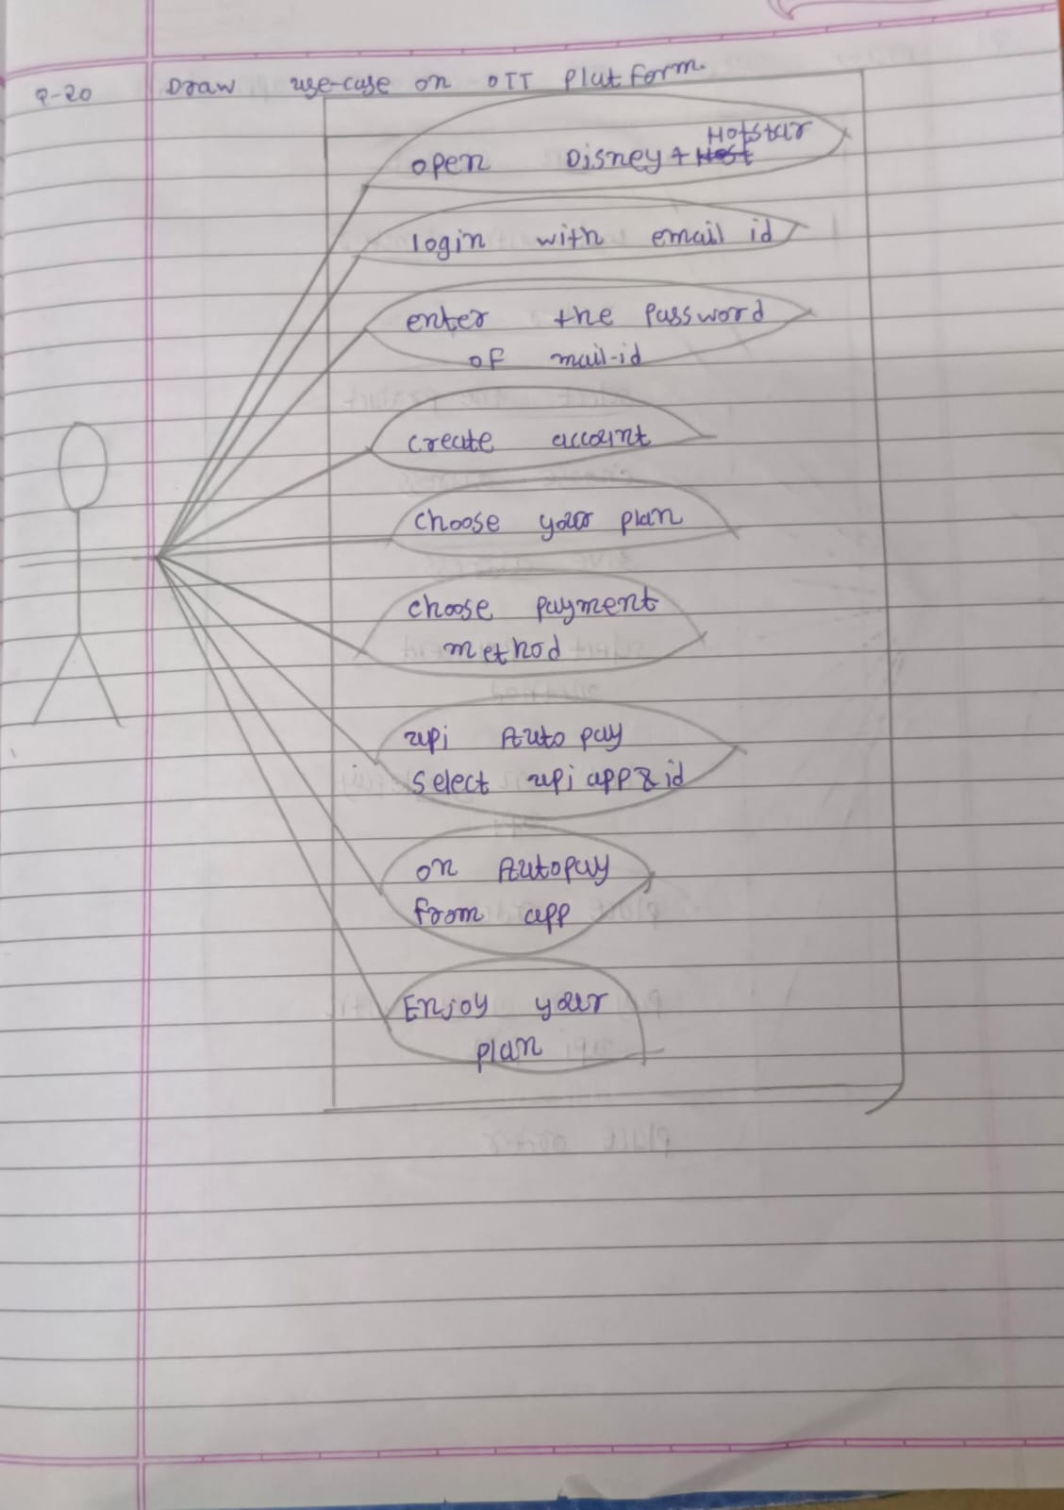

1. Draw use case on E-commerce application

* 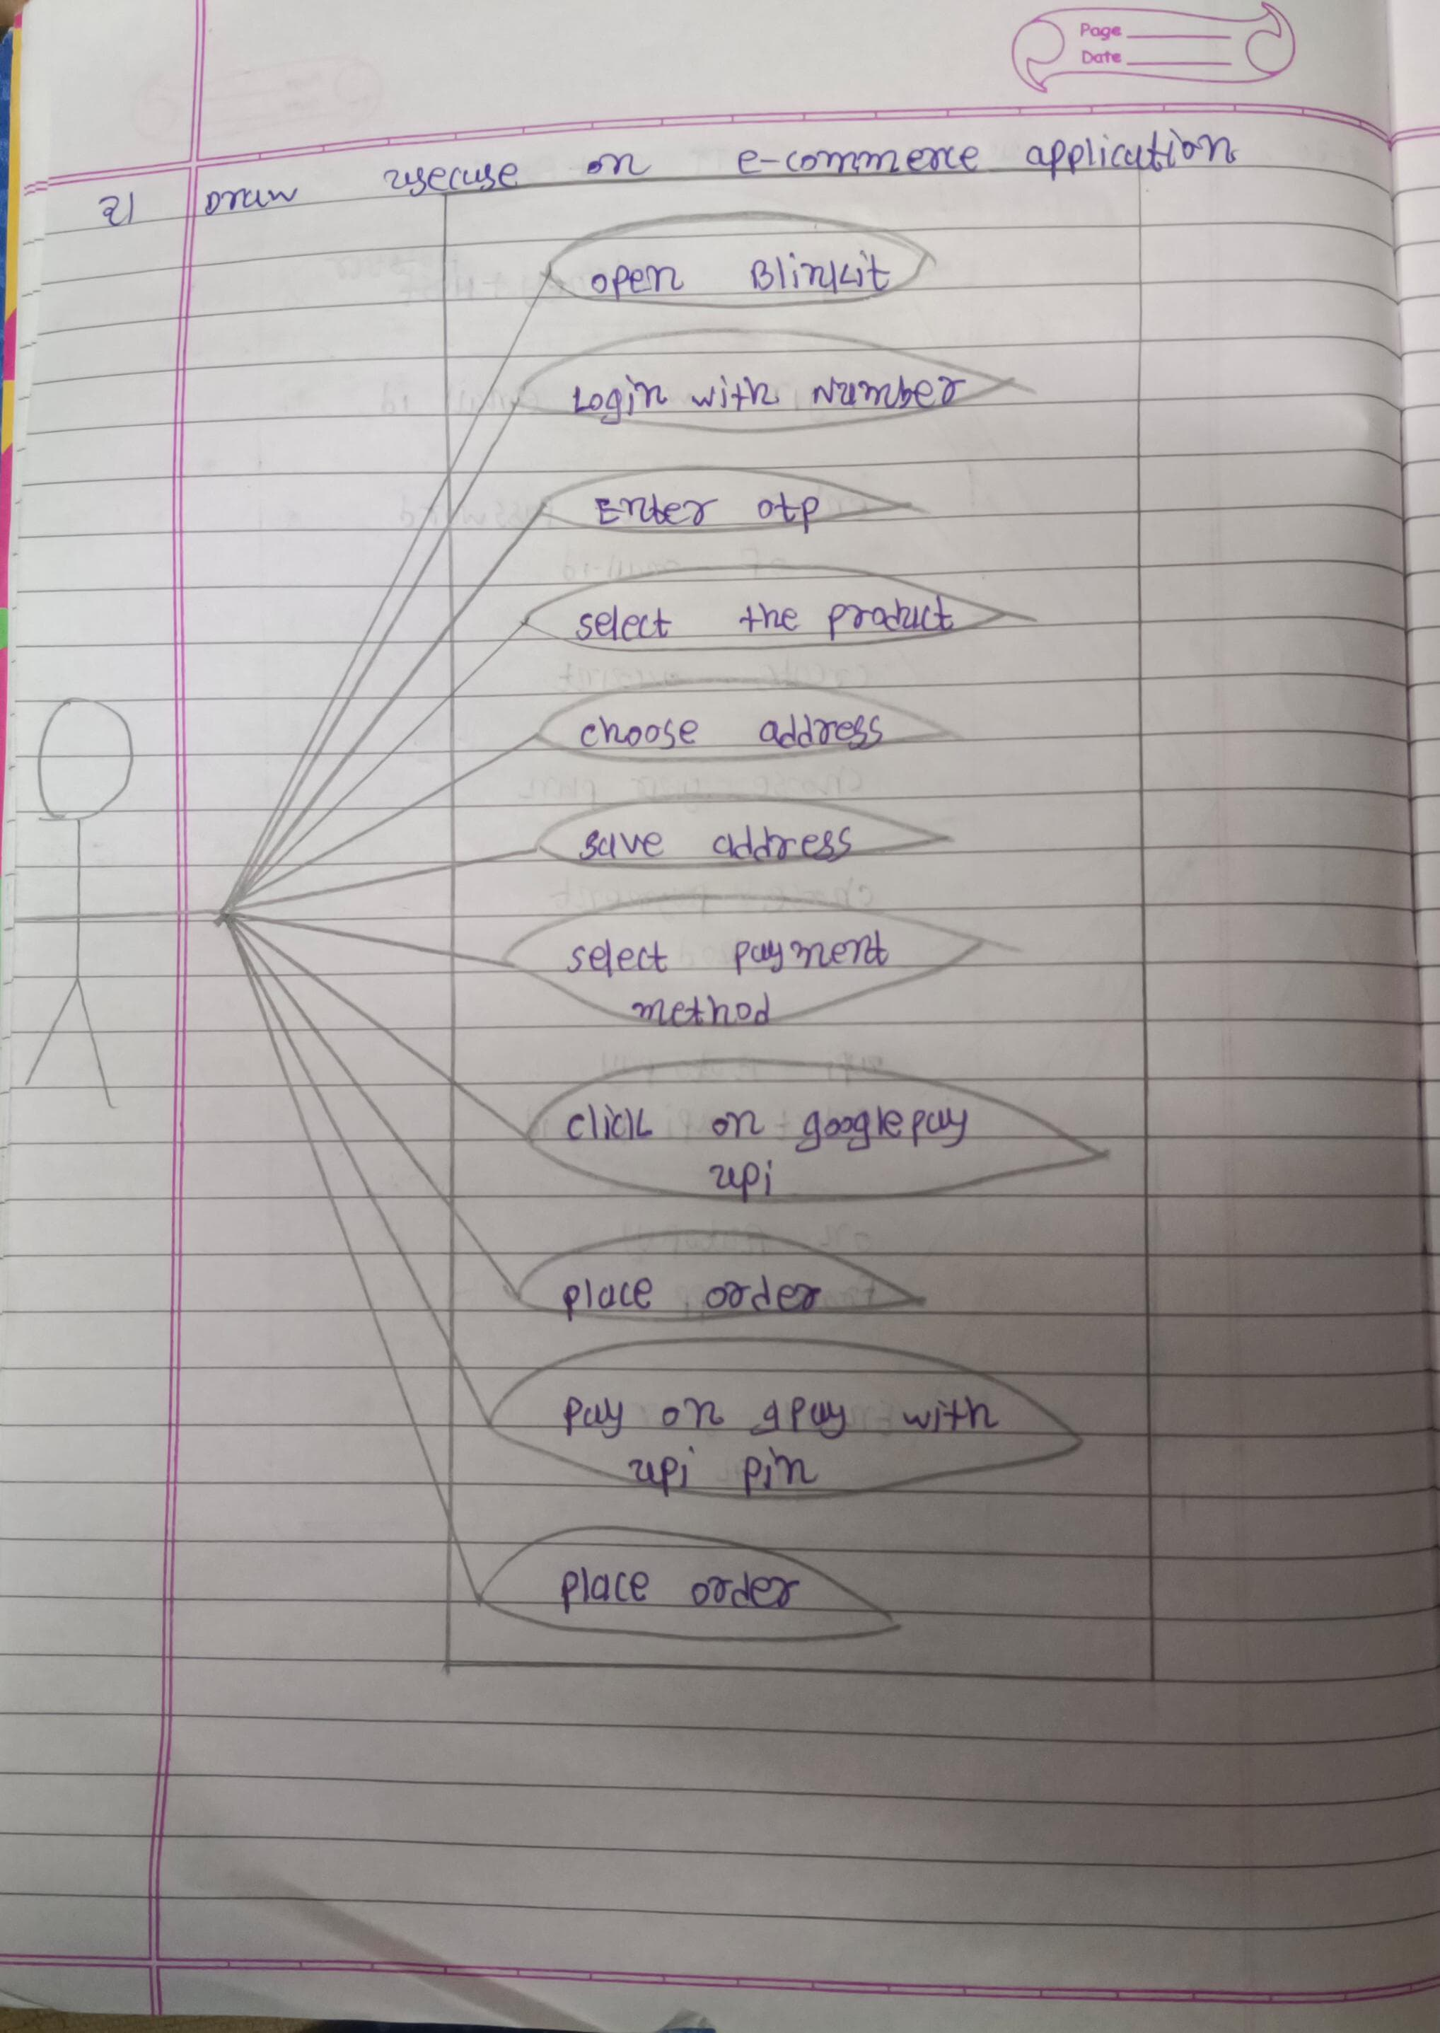

1. Draw use case on Online shopping product using payment gateway.

